Title: Vision’s Fragility
Artist: Antonio Yaghy, MD

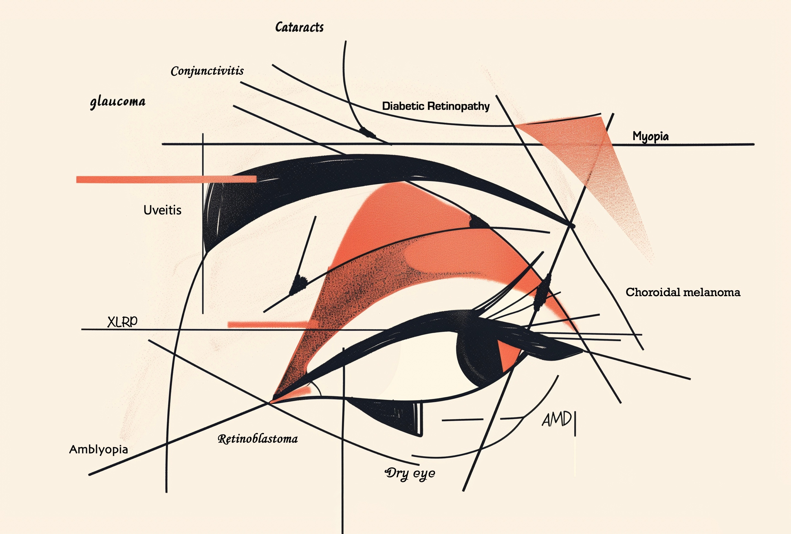

Artist Description:
"Vision's Fragility" is a digital illustration that combines abstract design elements with meaningful text. The focal point of the image is a striking representation of a human eye, composed mainly of geometric shapes and lines. The predominant use of black, accented with touches of bold red and soft peach tones, creates a visually compelling contrast that suggests both the fragility and the inherent vitality of human sight. Intersecting lines cut through the eye, drawing the viewer's attention to carefully placed text that lists various eye conditions, such as age-related macular degeneration (AMD), glaucoma, cataracts, diabetic retinopathy, and X-linked retinitis pigmentosa. Each eye condition is thoughtfully written in a distinct font, adding depth and character to the artwork. The varied typography not only enhances the visual appeal but also symbolizes the unique challenges and experiences associated with each condition, emphasizing that each person's journey with sight is deeply personal and complex.

