Title: Focus
Artist: Swetha Sriramoju

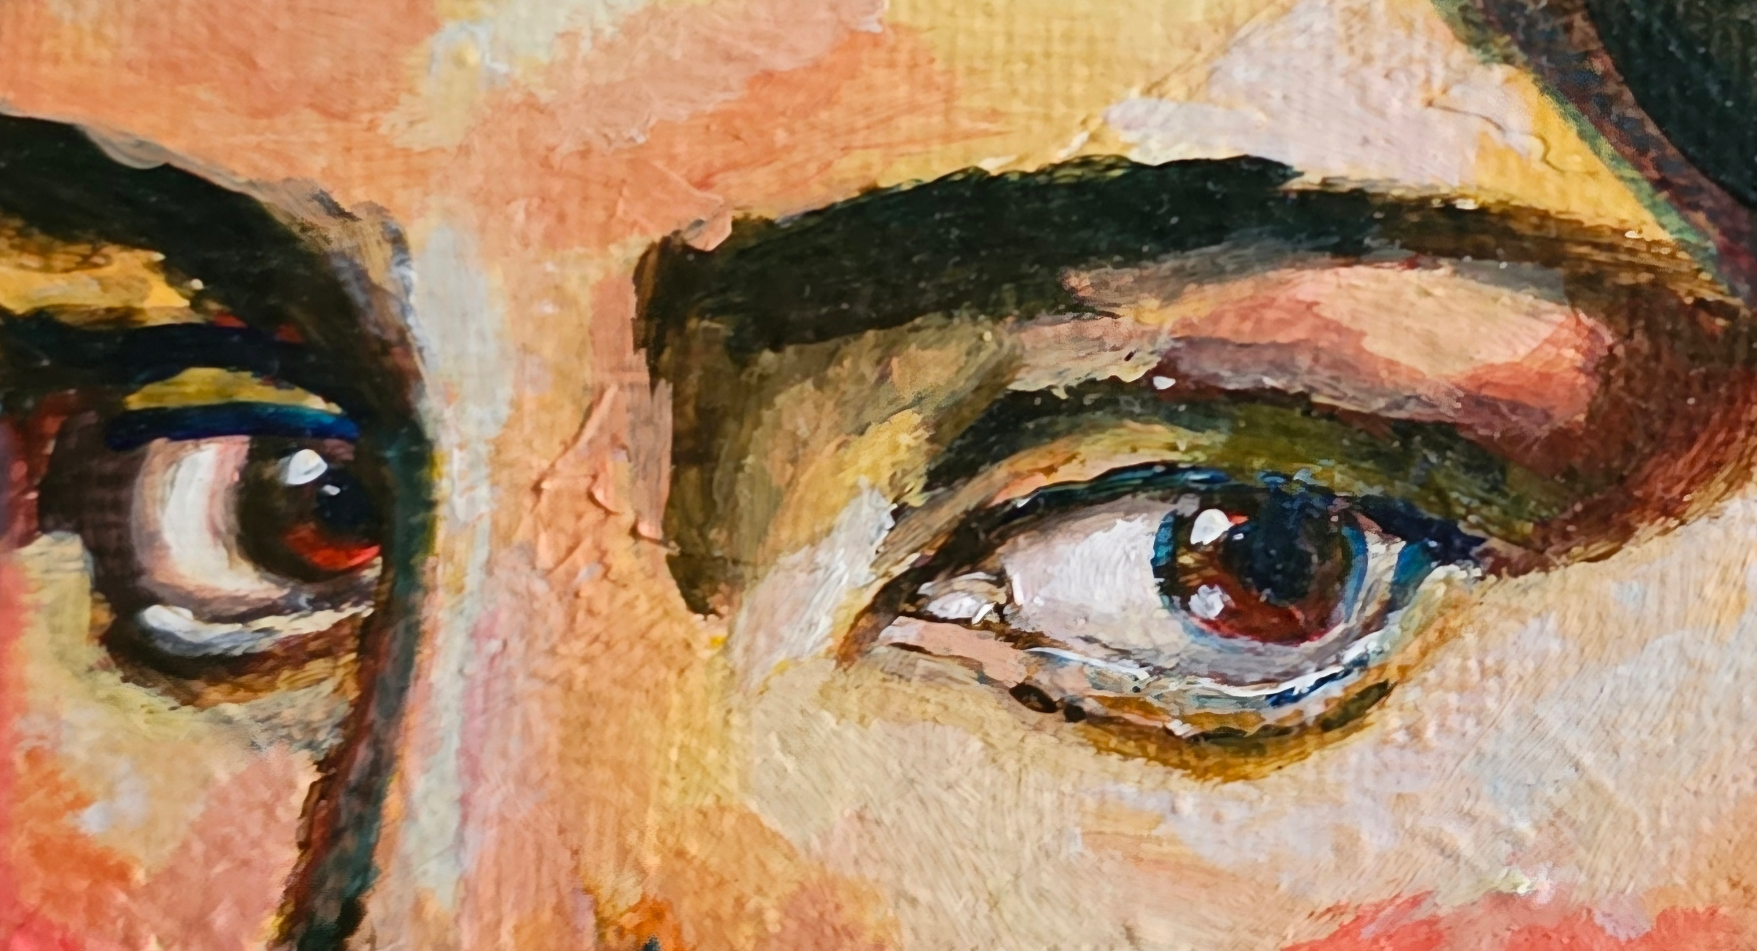

Artist Description:
This painting illustrates the subtle movements of our eyes as they glance to the side, and how our eyes express our emotions and inquisitivity. The painting was created in acrylic paint and embraces the use of strong contrasting color to capture dimension and depth.

