Title: Clarity
Artist: Swetha Sriramoju

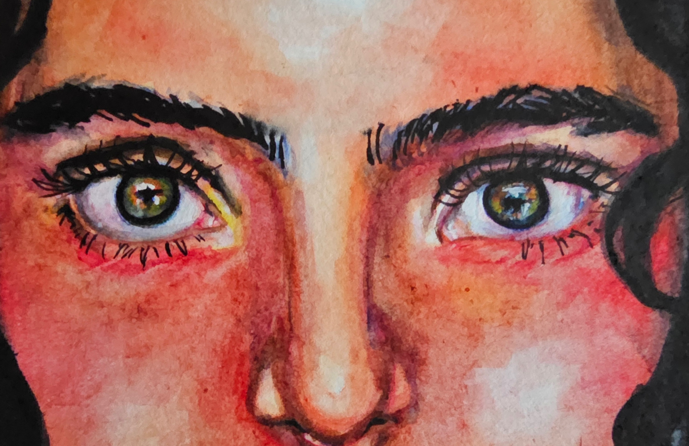

Artist Description:
This painting captures the range of color and contrast depicted in our eyes. Watercolor paint and ink were used to illustrate the depth and reflections seen in our eyes, capturing the variety of colors of the iris.

